**Jaydeep Mahajan-CE066-IP-LAB3**

**Aim: Implement following Image Enhancement Techniques using Octave**.

1. Contrast Stretching

2. Intensity Level Slicing

3. Bit Plane Slicing Functions

1) round (X): This function rounds the value of X to the nearest integer. Example: variable = round (0.75); % variable becomes 1 since 0.75 > 0.50.

2) bitget (image, i): This function returns the status of bit(s) ‘I’ of the unsigned integers in “image”. Example: bitplane_i = bitset(orig_img , bit);

GENERAL EQUATION OF CONTRAST STRETCHING: Slope of the Line: m=(y2–y1)/(x2– x1) = ( smax-smin )/( rmax-rmin ) Putting the above values in the equation of line Y = ( m * X ) + c we get s = ( ( (smax-smin) / (rmax-rmin) ) * (r- rmin) ) + smin

**Task1:** Do contrast stretching For the Image given in Figure 3.10 of the Textbook. Obtain Contrast stretched Image from Low contrast Image as given in Figure 3.10 (c).

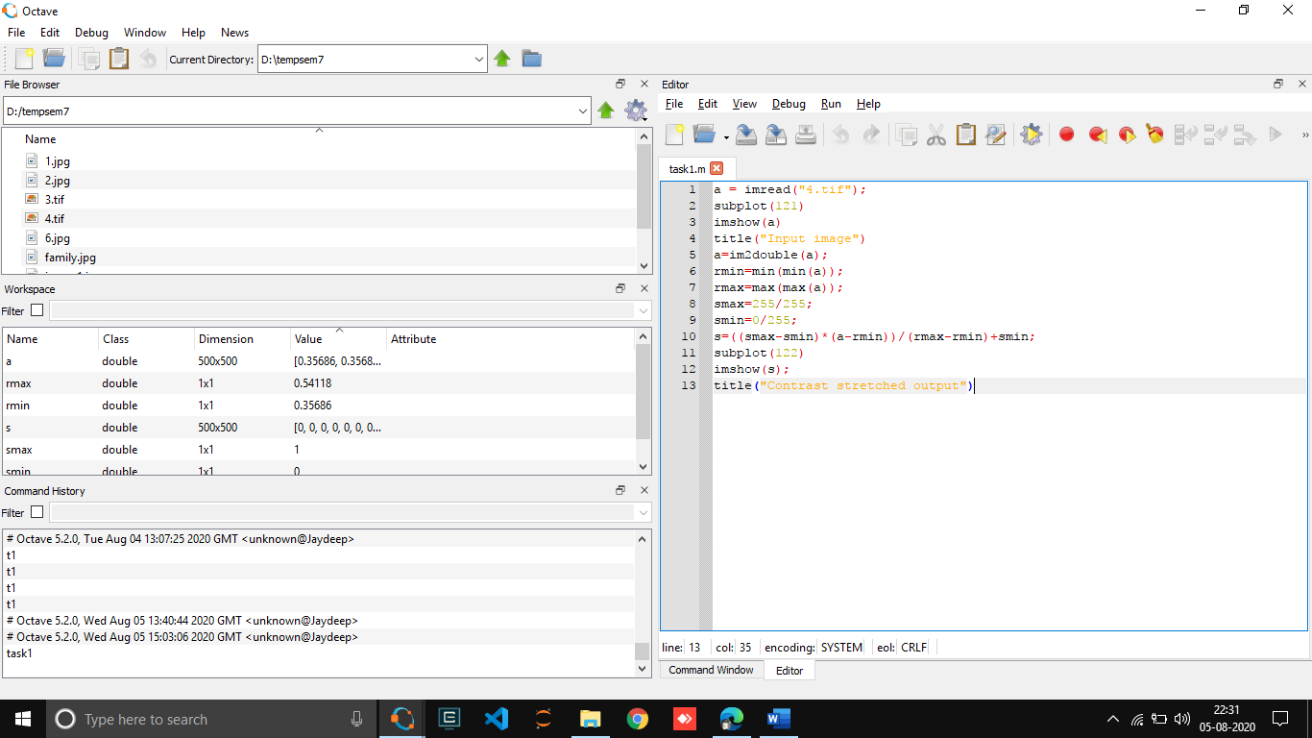

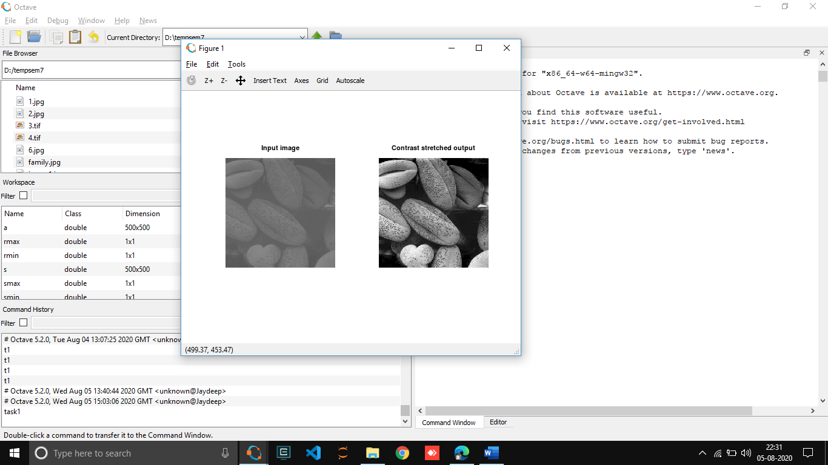  
  
  
  
  
  
  
  
  
  
  
  
  
  
  
  
  
  
  
  
  
  
  
  
  
  
  
  
  
  
  
  
  
  
  
  
  
  
  
  
  
  
  
  
  
  
  
  
  
  
  
  
  
  
  
  
  
  
  
  
  
  
  
  
  
  
  
  
  
  
**Task 2:** Take any family photo of yours – convert it into grayscale- reduce its contrast by using the function that was defined during lab session. Enhance the contrast of that image using piecewise linear operation for contrast stretching.

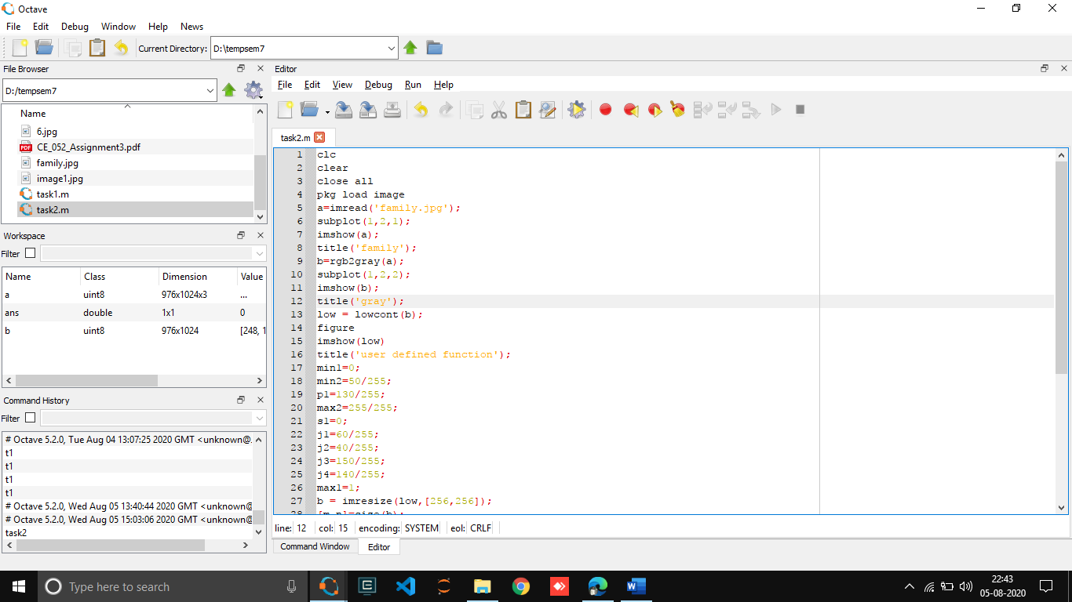

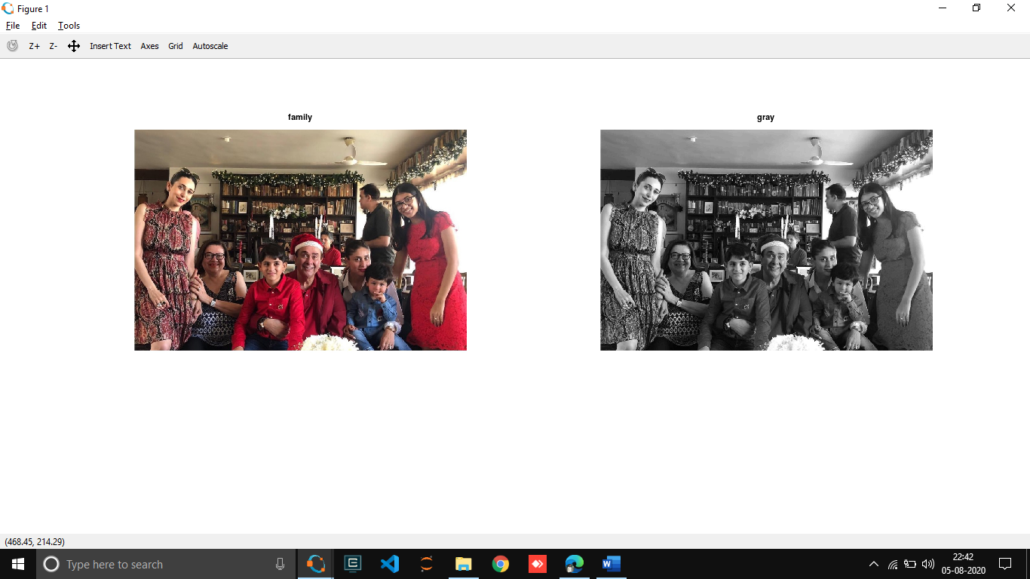  
  
  
  
  
  
  
  
  
  
  
  
  
  
  
  
  
  
**Task 3:** Apply thresholding to any of your grey scale photo.

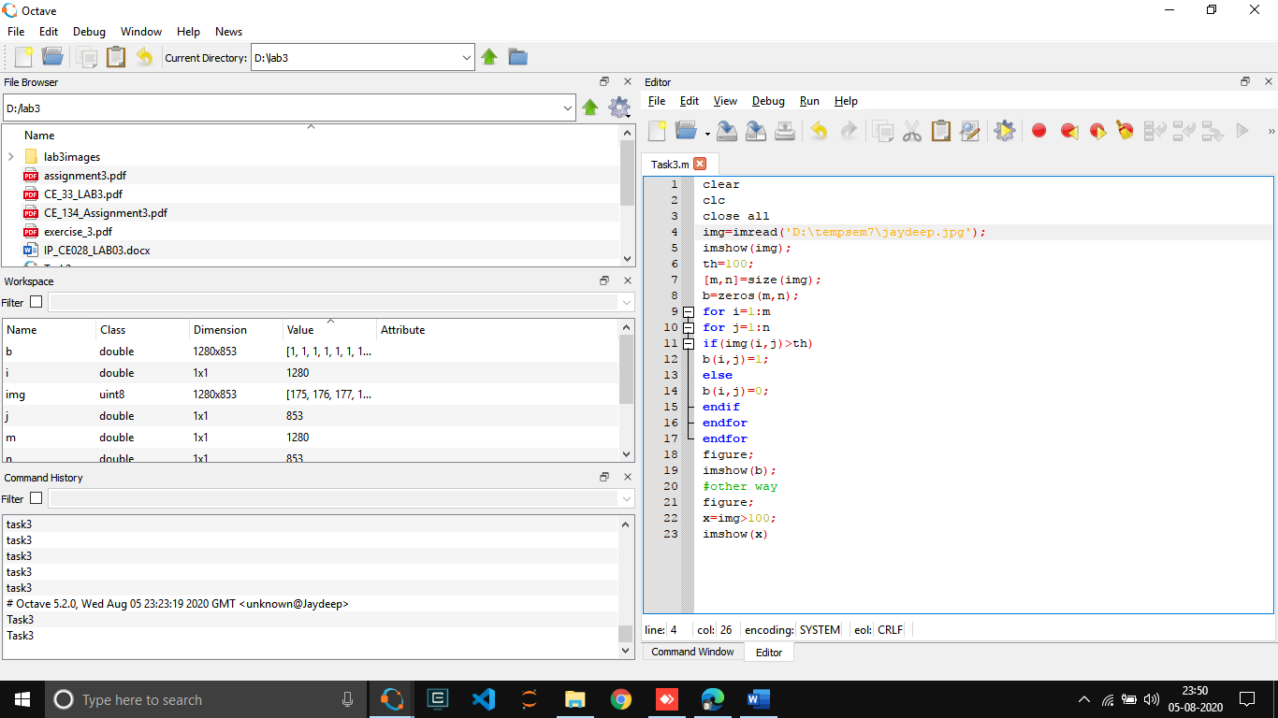

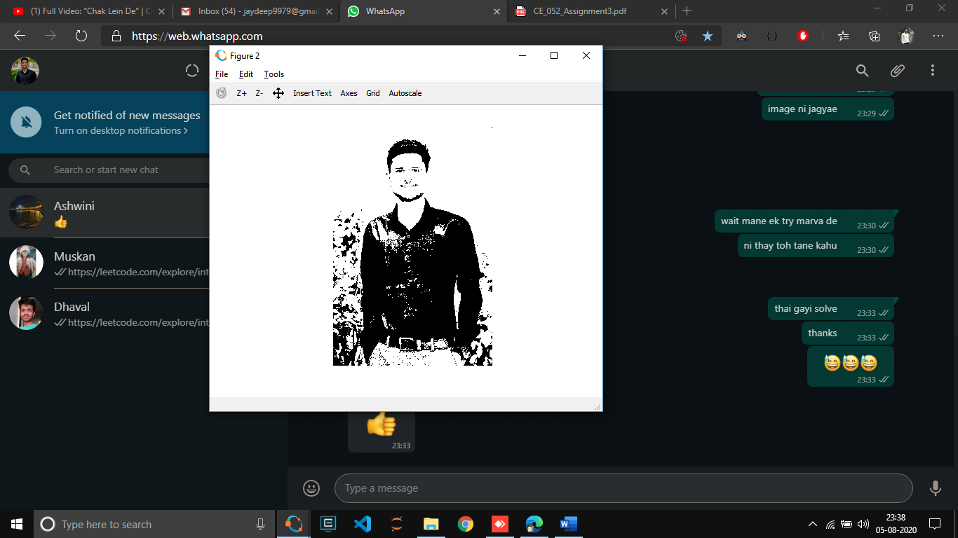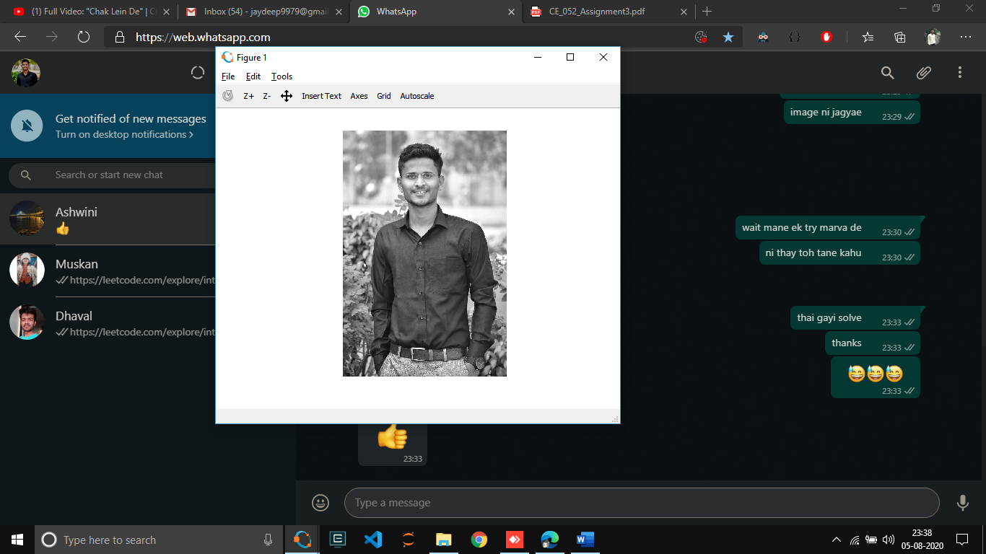

**Task 4:** Take your photo and separate out its bit plains. Reconstruct the given image using higher order 2-bit planes. Reconstruct the given image using higher order 4-bit planes. Experiment with the bit planes and derive your conclusions.

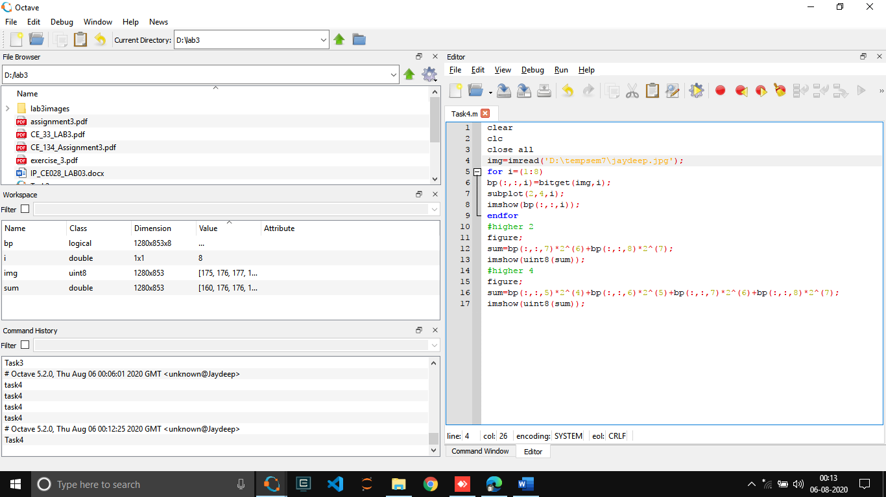

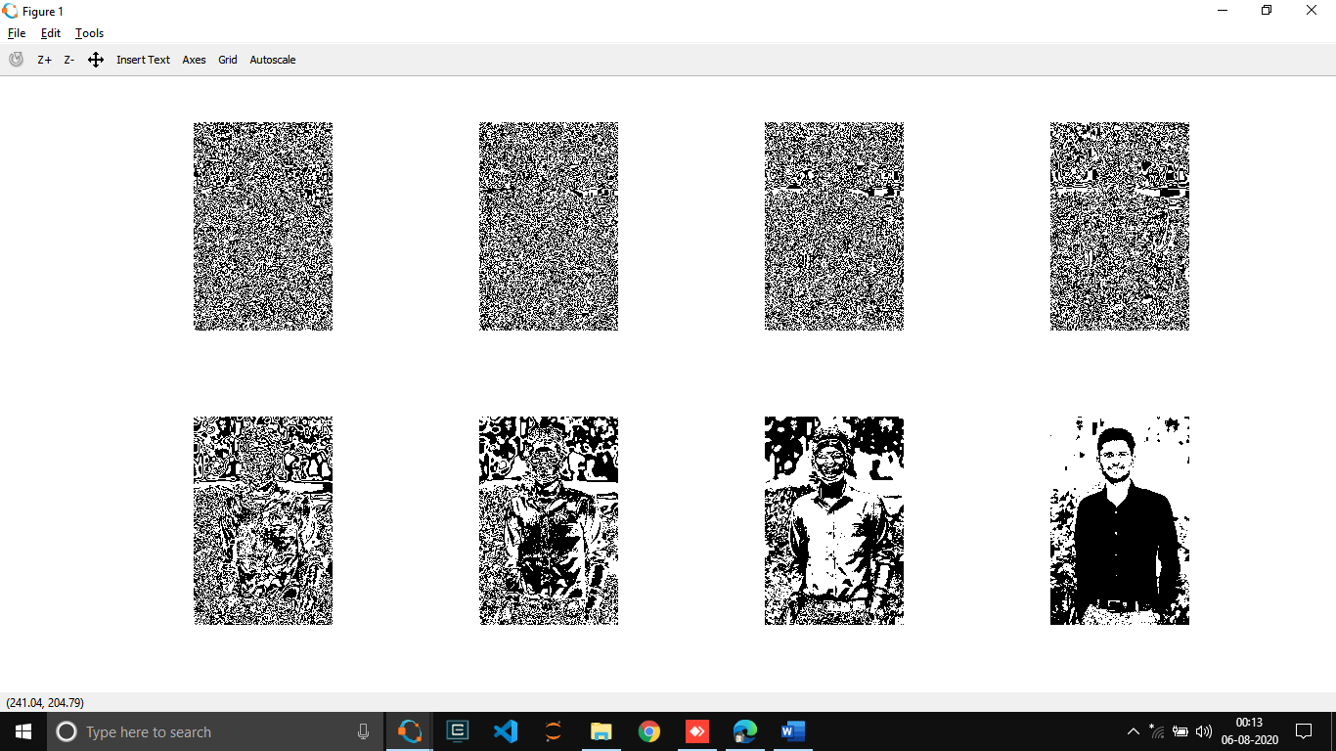

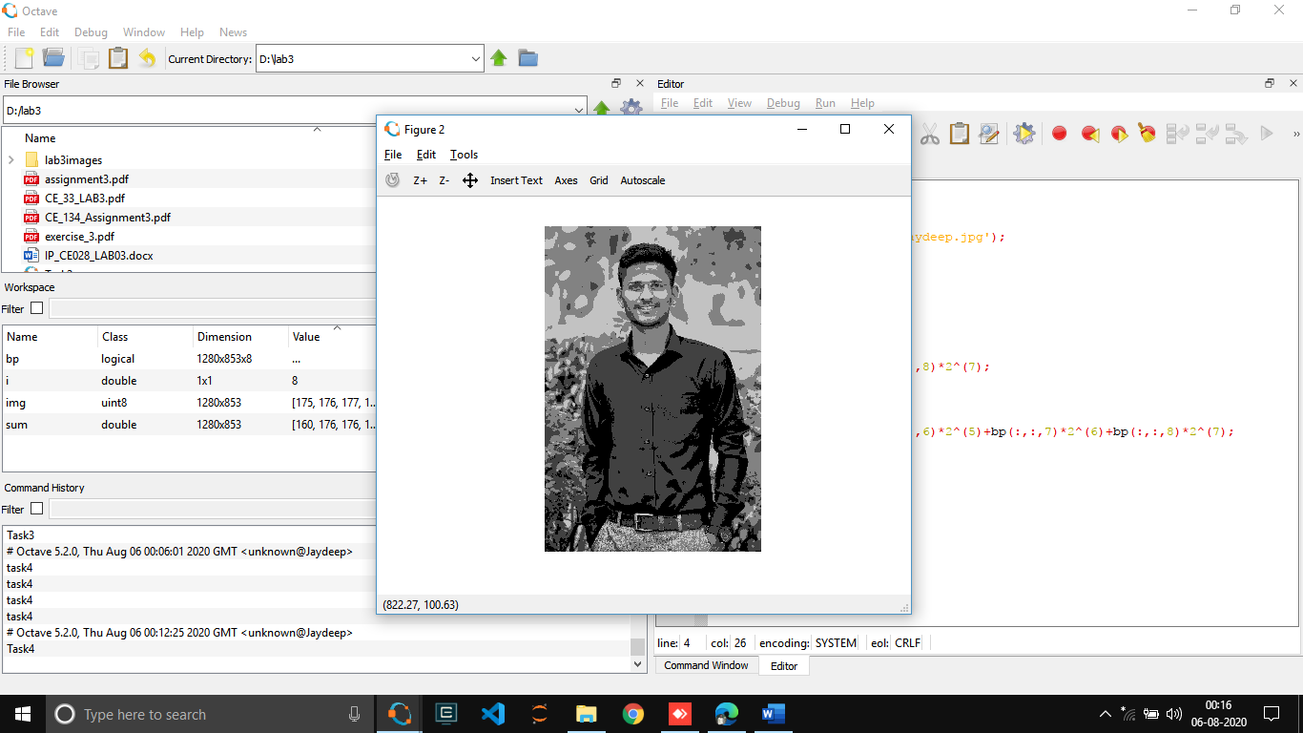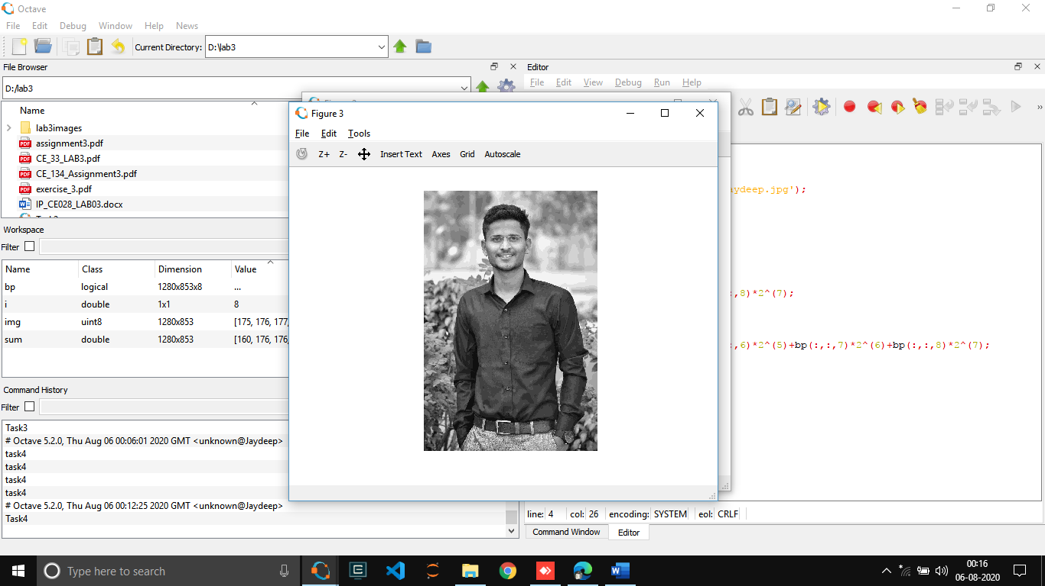   
   
  
  
  
  
  
  
  
  
  
  
  
  
  
  
  
  
  
  
  
  
  
  
  
  
  
  
  
  
  
  
  
  
  
  
  
  
  
  
  
  
  
  
  
  
  
  
  
  
  
  
  
  
  
  
  
  
  
**Task 5:** Perform intensity slicing to separate out red green balloons form the image 1(check: lab3images) given.

